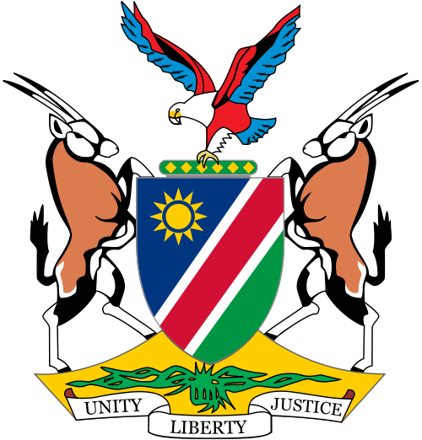

**MINISTERIAL**   **STATEMENT**

**BY**

**HON. TJEKERO TWEYA**

**MINISTER OF INFORMATION AND COMMUNICATION TECHNOLOGY ON THE CORRECT WAY OF DISPLAYING AND HANGING THE PRESIDENTS PORTRAITS IN GOVERNMENT OFFICES AND PUBLIC BUILDINGS.**

**Hon Speaker**, Honourable **members**, thank you for the opportunity to address the august house this afternoon.

Firstly I would like to thank Hon. Clara Gowases for her observation regarding the hanging of portraits of the Founding President, Former President and the current President in Government offices.

Cabinet Committee on Overall Policy and Priorities (CCOPP) on 19 April 2016 directed that all the portraits of the serving President and former Presidents should be displayed together. The directive stated as

follows:” **The serving President should be displayed above the former Presidents who will be displayed on the left hand side of the serving President in a sequential order**”.

Furthermore, the portraits of the serving President and former Presidents should be displayed at designated areas at State House, boardrooms of all O/M/As, school staff rooms and libraries as well as Regional Council and Local Authorities Offices. Consequently, the Ministry of Information and Communication Technology on the same day, the 19th April 2016 sent a letter to all Offices/Ministries/Agencies (O/M/As) to obtain authentic portraits of the Serving President and the Former Presidents from the Ministry’s Regional Offices countrywide.

However, as for the Founding President, the “**copyrigh**t “remains with the private photographer, Gerhard Botha Photographers and therefore the Ministry does not print nor sell the Founding Father’s portrait. Furthermore, on 29 August 2016 the Ministry again used the New Era Feedback Page to inform the public on the correct way of displaying these portraits.

Apart from informing the public on the correct way of hanging the portraits, the Ministry on the 15th July 2016 placed a notice in the local newspapers namely New Era, The Namibian, Die Republikein and Namibian Sun about the availability of both framed and unframed Portraits of the current and former Presidents and the prices of the different sizes.

The prices were given as follows:

Framed portrait (size A2): N$ 400-00

Frame portrait (size A3): N$ 320-00

Unframed portrait (size A2): N$ 100-00

Unframed portrait (size A3): N$ 50-00

This saw many people flocking to our offices both in Windhoek and in the regions to buy these portraits until they were out of stock.

Due to unavailability of funds, the Ministry currently only has unframed portraits in stock at all our regional offices countrywide available for purchase and members of the public have been advised to buy and frame at own cost.

Here is the correct display of the portraits as per the CCOPP directive:

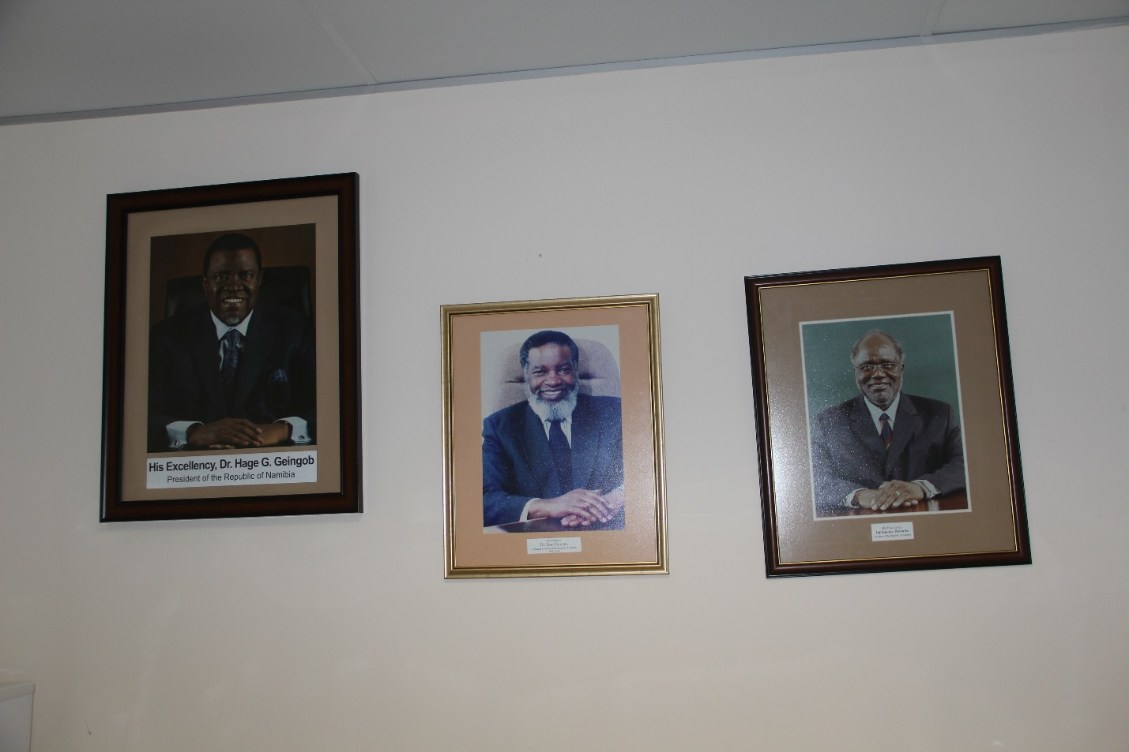

I thank you